**U.S. economy expanded 1.9 percent in fourth quarter, 2016 GDP rises 1.6 percent**

*The Washington Post* - [Ana Swanson](https://www.washingtonpost.com/people/ana-swanson/) - January 27, 2017

The U.S. economy expanded 1.9 percent between October and December, government data showed Friday morning, capping off a long period of tepid expansion under the Obama administration. Growth in the gross domestic product, the total output of goods and services in the country, was just below average growth of 2.1 percent seen since the beginning of 2010.

“I know most people say ‘Oh, 2 percent isn’t that great,’ but in the current world it is. Many countries would be envious,” said Beata Caranci, chief economist at TD Economics.

The reading fell short of expectations of economists surveyed by Bloomberg News, who had forecast 2.2 percent annualized growth in the period. For the full-year 2016, the economy expanded 1.6 percent, government data showed, down from an increase of 2.6 percent the prior year.

The data was the first reading from the Commerce Department and will be revised twice more in coming months. The economy surged to 3.5 percent growth in the third quarter, driven partly by an unusually large volume of soybean exports.

Economists look fairly positively on the progress that the U.S. has made since the recession, but current GDP growth is still far below [the 4 percent](https://www.whitehouse.gov/bringing-back-jobs-and-growth) target President Donald Trump has said he is aiming for. To reach that ambitious target, the U.S. will have to overcome significant challenges, like a working age population that is shrinking as Baby Boomers retire, and sluggish productivity growth, economists said.

“It’s hard to orchestrate 4 percent on a long-term sustained basis,” said Caranci. “You would need a paradigm shift in productivity growth” – a substantial increase in immigration, to bring younger workers into the labor force.

While GDP growth has been somewhat tepid, data from the jobs market gives a picture of a stronger economy. In December, the U.S. labor market saw its [75th straight month](https://www.washingtonpost.com/news/wonk/wp/2017/01/06/u-s-added-156000-jobs-in-december-unemployment-rate-ticked-up-to-4-7-percent/?utm_term=.87208ec22f37) of job growth, while wages rose 2.9 percent from the year before.

“The economy is growing at a clearly above-trend pace, meaning we’re using up labor-market slack, and you can see it in the employment numbers, and you can see it in general growth numbers. A year ago, there was a bit more of a question mark around that,” said Jan Hatzius, chief economist at Goldman Sachs. “Now we’ve moved beyond that.”

Hatzius said it is clear the U.S. is “at least in the neighborhood” of full employment, the point at which most people in the U.S. who want a job will have one. “If we get continually strong growth, and especially if that is boosted further by tax cuts and spending increases, then the Fed is going to want to lean against that,” he said.

The U.S. Federal Reserve is unlikely to raise rates at its meeting next week, analysts say, but it could hike rates two or three times in 2017 to offset the risk of inflation in a strengthening economy. Those moves may depend heavily on whether the Trump administration rolls out policies that could further stoke inflation, including tax cuts and infrastructure spending.

“We're operating under a cloud of uncertainty at the moment, and we have to wait and see what changes occur and factor those into our decision-making as we gain more clarity,” Janet Yellen, the chair of the Federal Reserve system, said at a news conference in December.

**U.S. Economy Returns to Lackluster Growth**

**President Trump has set goal of generating 4% annual growth by overhauling tax code and rolling back regulations, among other measures**

*The Wall Street Journal* - Ben Leubsdorf – January 27, 2017

The U.S. ended 2016 on a familiar trajectory of roughly 2% economic growth, the lackluster trend that has prevailed through most of the current expansion and which President Donald Trump is seeking to double in the face of stubborn long-term headwinds.

Gross domestic product, a broad measure of the goods and services produced across the economy, expanded at an inflation and seasonally adjusted annual rate of 1.9% in the fourth quarter from the previous three months, [the Commerce Department said Friday](https://bea.gov/newsreleases/national/gdp/gdpnewsrelease.htm). That exceeded the pace of growth in a weak first half of 2016 but marked a slowdown from a fleeting [third-quarter 3.5% growth spurt](http://www.wsj.com/articles/u-s-third-quarter-gdp-revised-up-to-3-5-gain-1482413502).

The economy similarly grew 1.9% in the fourth quarter compared with a year earlier, matching 2015’s annual growth and in line with the 2.1% average since the recession ended in mid-2009. That has made this [the slowest expansion since World War II](http://blogs.wsj.com/economics/2016/07/29/seven-years-later-recovery-remains-the-weakest-of-the-post-world-war-ii-era/), though also one of the longest.

The final three months of 2016 saw solid consumer spending, a pickup in business investment, a rebound for [home construction](http://www.wsj.com/articles/housing-starts-jumped-in-december-capping-best-year-since-2007-1484835917) and stronger spending by state and local governments. A widening in the foreign-trade deficit weighed on growth, offset in part by a buildup in business inventories.

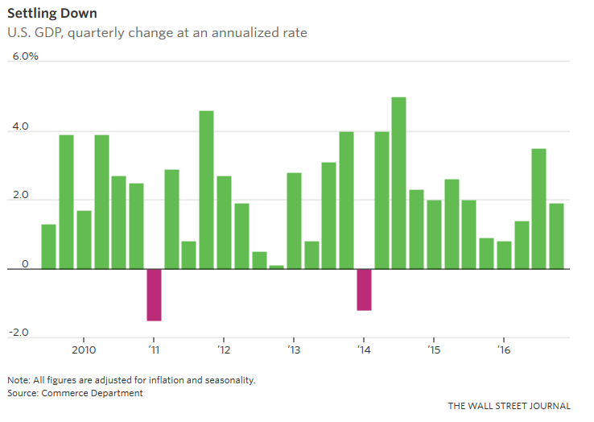

Settling DownU.S. GDP, quarterly change at an annualized rate

THE WALL STREET JOURNAL

Source: Commerce Department

Note: All figures are adjusted for inflation and seasonality.

“With a business-friendly administration and Congress, are we witnessing a return to animal spirits as we head into the new year?” asked Beth Ann Bovino, U.S. chief economist at S&P Global Ratings. “That remains to be seen, but it does suggest some promise.”

The latest data underscored the obstacles to stronger growth facing Mr. Trump, who [has said he will raise the pace of expansion to 4% a year](http://www.wsj.com/articles/for-donald-trump-challenges-lurk-in-a-sturdy-economy-1484848525). Friday’s report also provided fodder for Republicans arguing that stronger growth is needed and possible. “Americans spoke loudly and clearly in November telling the world that President [Barack] Obama’s ‘new normal’ was unacceptable,” said Rep. Pat Tiberi (R., Ohio), chairman of Congress’s Joint Economic Committee. “That’s why Republicans are ready to unleash America’s economic potential.”

Mr. Trump has argued the U.S. can achieve stronger growth by overhauling the tax code, boosting infrastructure spending, rolling back federal regulations and cutting new trade deals that narrow the foreign-trade deficit.

Economic forecasters are predicting slightly stronger growth in the next few years compared with pre-election estimates. But [many remain skeptical of the potential for a significant shift](http://www.wsj.com/articles/aging-population-stagnant-productivity-challenge-donald-trumps-growth-plan-1480871527) in the long-term growth picture.

Federal Reserve Chairwoman Janet Yellen last week [pointed to “a variety of forces depressing both supply and demand,”](https://www.federalreserve.gov/newsevents/speech/yellen20170119a.htm) including slow growth in the size of the labor force and sluggish worker productivity. She said she expected they would continue to restrain growth for years to come. The nonpartisan Congressional Budget Office [this week reiterated](http://www.wsj.com/articles/cbo-sees-budget-deficit-seen-falling-to-559-billion-in-2017-1485270072) that it thinks U.S. economic growth will remain modest over the coming decade due to long-term forces, namely the slower workforce growth produced by baby-boomer retirements.

“A combination of across-the-board tariffs, corporate tax reform and lower tax rates, and infrastructure spending—the whole package could boost growth,” said Michael Gapen, chief U.S. economist at Barclays. “The real question is, does that turn out to be a short-term boost, or does it improve productivity growth and rates of potential growth at the same time?”

He said the economy’s underlying growth rate is likely in the range of 1.5% to 2%, and it’s “not totally impossible” to raise that trend.

